Hardware Prototype Status
A prototype PCB (V1 revision) was fabricated by JLCPCB from KiCad-generated Gerber files and hand-assembled in the university electronics laboratory by Mr. John Maloco. The board measures 60.5 × 42.5 mm on a two-layer stackup with a continuous ground plane on the bottom layer. Figure 5.3 shows the completed V1 prototype. The V1 board was ordered before the OVLO protection subcircuit and several supporting components were finalised; Table 5.9 provides a complete cross-referenced inventory of all components, mapping KiCad and LTspice reference designators and indicating the population status on the V1 board.
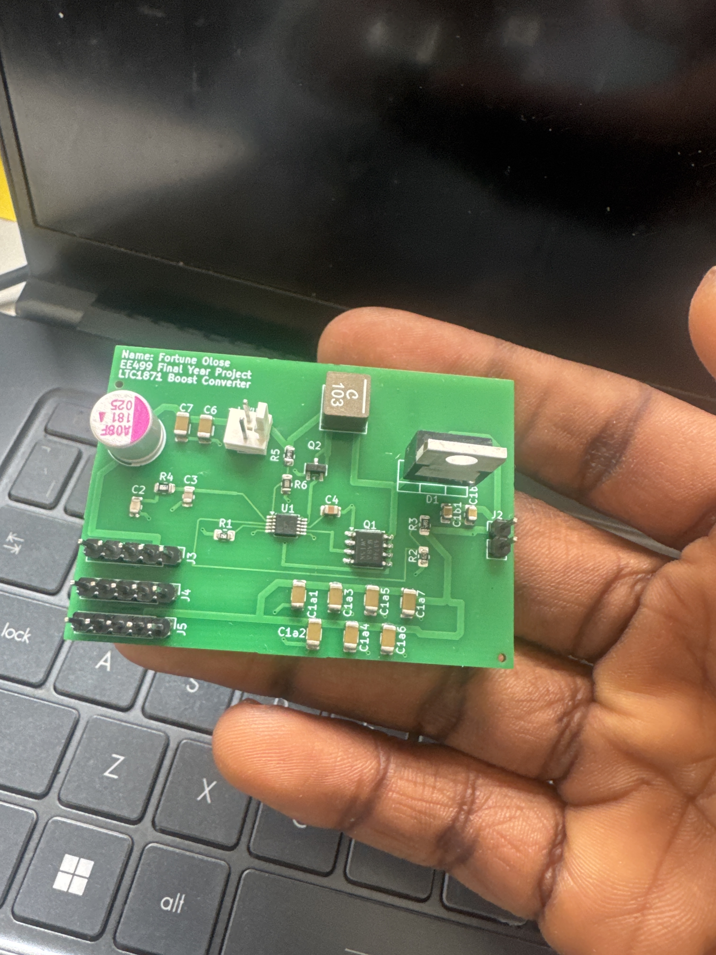
Figure 5.3 — Assembled V1 prototype PCB (60.5 × 42.5 mm). Power stage, feedback, compensation, and UVLO components populated. OVLO subcircuit (D3, Q4, R7–R9), PMOS bypass diode (D2), and output electrolytic (C5) not present on this revision.
Note: the KiCad schematic and LTspice simulation use different reference designators for several components. Table 5.9 provides both to avoid ambiguity. Key differences include the UVLO divider (R5/R6 in KiCad, R6/R7 in LTspice), the power MOSFET (Q1 in KiCad, M1 in LTspice), the PMOS (Q2 in KiCad, M2 in LTspice), and the OVLO NPN transistor (Q4 in KiCad, Q1 in LTspice).
KiCad Ref | LTspice Ref | Component | V1 Status | Function
U1 | U1 | LTC1871EMS (MSOP-10) | Present | Controller
Q1 | M1 | SI4894BDY (SO-8) | Present | Power MOSFET
Q2 | M2 | DMP3099L (SOT-23) | Present | Reverse polarity PMOS
D1 | D1 | MBR735 (TO-220) | Present | Schottky rectifier
L1 | L1 | XAL6060-103MEC (10 µH) | Present | Inductor (shielded)
R1 | R1 | 68.1 kΩ (0805) | Present | FREQ set (350 kHz)
R2 | R2 | 56 kΩ (0805) | Present | FB lower divider
R3 | R3 | 499 kΩ (0805) | Present | FB upper divider
R4 | R4 | 8.66 kΩ (0805) | Present | Compensation resistor
R5 | R6 | 49 kΩ (0805) | Present | UVLO upper divider
R6 | R7 | 10 kΩ (0805) | Present | UVLO lower divider
C1 | Cin | 100 µF electrolytic | Present | Input bulk capacitor
C2 | C2 | 6.8 nF (0805) | Present | Compensation (ITH zero)
C3 | C3 | 100 pF (0805) | Present | Compensation (ITH pole)
C4 | C4 | 4.7 µF (0805) | Present | INTVCC bypass
C6 | — | 22 µF MLCC (1206) | Present | Input HF decoupling
C7 | — | 22 µF MLCC (1206) | Present | Input HF decoupling
C1a1–C1a7 | C1a | 7× 22 µF MLCC (1206) | Present | Output MLCC bank
C1b1–C1b2 | C1b | 2× 10 µF MLCC (0805) | Present | Output MLCC bank
J2 | — | Output connector | Present | Load connection
J3–J5 | — | Pin headers | Present | Debug access
D2 | D2 | SS14 Schottky (SMA) | Missing | PMOS body diode bypass
D3 | D3 | BZX84C10V Zener (SOT-23) | Missing | OVLO clamp
Q4 | Q1 (LTspice) | MMBT3904 NPN (SOT-23) | Missing | OVLO clamp transistor
R7 | R8 | 10 kΩ (0805) | Missing | PMOS gate pulldown
R8 | R9 | 5.38 kΩ (0402) | Missing | OVLO base pulldown (RB)
R9 | R10 | 10 kΩ (0402) | Missing | Zener current limiter
C5 | C5 | 100 µF electrolytic | Missing | Output bulk capacitor
Table 5.9 — V1 prototype component population status with KiCad/LTspice cross-reference
The V1 prototype validates the physical design of the core converter. All surface-mount footprints (MSOP-10 for U1, SO-8 for Q1 and Q2, SMA for D1, 0805 and 0402 passives) align correctly with their respective packages. The XAL6060-103MEC inductor fits within its designated footprint and clears adjacent components. The output MLCC bank (C1a1–C1a7, C1b1–C1b2) and input capacitor bank (C1, C6, C7) are correctly placed along the high-current path. The prototyping headers (J3–J5) provide accessible measurement points for future bench testing.
The seven missing components fall into three categories. First, the complete OVLO subcircuit (D3, Q4, R7, R8, R9) was designed and validated in LTspice after the V1 board had been ordered. Without these components, the V1 board has no overvoltage protection — the converter will regulate at any input voltage above the UVLO threshold, with no upper limit. Second, the PMOS body diode bypass D2 is absent. In the original schematic, D2 was a 1N5818 in a through-hole DO-41 package; this has since been replaced with an SS14 Schottky in a compact SMA (DO-214AC) surface-mount package in the updated V2 schematic, making it compatible with automated SMD assembly on the revised board. Without D2, the body diode of Q2 carries the full load current during startup, resulting in slightly higher conduction loss and slower turn-on. Third, the output bulk electrolytic C5 (100 µF) is missing, reducing the total output capacitance and increasing load transient droop compared to the simulation model.
Following the completion of the V1 prototype, the KiCad schematic was updated to reflect the final validated design. Key changes include the addition of the complete OVLO subcircuit, the replacement of D2 from a through-hole 1N5818 (DO-41) to an SMD SS14 (SMA), and the correction of R8 from 10 kΩ to 5.38 kΩ to set the OVLO trip point at 11.1 V. A JLCPCB bill of materials and component placement file have been prepared for the V2 revision, with all SMD components sourced from LCSC inventory. The V2 board has not yet been fabricated.
Electrical bench testing of the V1 prototype was not performed within the project timeline. Output voltage measurement, efficiency characterisation, load transient capture, and thermal imaging under load remain as future work (Chapter 6). The prototype in its current state validates schematic-to-layout translation, the component procurement and sourcing workflow through Mouser IE and JLCPCB, and the manufacturing feasibility of the two-layer PCB design.
The V1 prototype demonstrates that the converter design can be physically realised on a compact two-layer PCB with commercially available components. A V2 revision incorporating the OVLO protection circuit, the SS14 bypass diode, the corrected R8 value, and the output bulk electrolytic, followed by comprehensive electrical bench testing, is recommended as the immediate next step.

